2017
Gender Statistics
The Examination Yuan
Republic of China (Taiwan)


Examination Yuan, Republic of China (Taiwan)
August 2018

CONTENT
Chapter 1 Civil Service Examinations 1
Chapter 2 Professional and Technical Examinations 9
Chapter 3 Civil Servants 11
Chapter 4 Screening and Review Results of Civil Servants Performance Evaluation 17
Chapter 5 Training and Development for Civil Servants 21
Chapter 6 Retirement and Survivor Relief of Civil Servants 28
Chapter 7 Personnel of Examination Yuan and Subordinate Agencies 31

LIST OF FIGURES
Figure 1-1 Percentages of registered candidates of Civil Service Examinations by type (2017) 1
Figure 1-2 Percentages of female registered candidates of Civil Service Examinations by type (2013-2017) 1
Figure 1-3 Examination attendance rate of Civil Service Examinations by type (2017) 2
Figure 1-4 Examination attendance rate of Civil Service Examinations by type (2013-2017) 2
Figure 1-5 Percentages of qualified examinees of Civil Service Examinations by type (2017) 3
Figure 1-6 Qualification rate of Civil Service Examinations by type (2013-2017) 3
Figure 1-7 Percentages of registered candidates of administrative personnel in Civil Service Examinations by type (2013-2017) 4
Figure 1-8 Percentages of registered candidates of technicians in Civil Service Examinations by type (2013-2017) 4
Figure 1-9 Percentages of qualified examinees of administrative personnel in Civil Service Examinations by type (2013-2017) 5
Figure 1-10 Percentages of qualified examinees of technicians in Civil Service Examinations by type (2013-2017) 5
Figure 1-11 Qualification rate of administrative personnel in Civil Service Examinations by type (2013-2017) 6
Figure 1-12 Qualification rate of technicians in Civil Service Examinations by type (2013-2017) 6
Figure 1-13 Percentages of qualified examinees of Special Civil Service Examinations by examination name (2017) 7
Figure 1-14 Percentages of qualified examinees of Special Civil Service Examinations by examination name (2013-2017) 7
Figure 1-15 Gender Disparity in the percentages of qualified examinees of Special Civil Service Examinations in select examination names 8
Figure 2-1 Percentages of registered candidates and qualified examinees of Senior Professional and Technical Examinations (2017) 9
Figure 2-2 Percentages of registered candidates and qualified examinees of Senior Professional and Technical Examinations by category (2017) 9

Figure 2-3 Percentages of registered candidates and qualified examinees of Junior Professional and Technical Examinations (2017) 10
Figure 2-4 Percentages of registered candidates and qualified examinees of Junior Professional and Technical Examinations by category (2017) 10
Figure 3-1 Civil servants by agency (end of 2017) 11
Figure 3-2 Percentages of female civil servants by agency (end of 2013-2017) 11
Figure 3-3 Percentages of female civil servants by county(city) (end of 2017) 12
Figure 3-4 Percentages of level of education of civil servants (end of 2017) ……………..12
Figure 3-5 Percentages of civil servants by rank (end of 2017) 13
Figure 3-6 Percentages of female civil servants by rank (end of 2013-2017) 13
Figure 3-7 Percentages of civil servants by age (end of 2017) 14
Figure 3-8 Percentages of civil servants as supervisors (end of 2017) 14
Figure 3-9 Percentages of indigenous civil servants by personnel category (end of 2017) 15
Figure 3-10 Percentages of disabled civil servants by personnel category (end of 2017) 15
Figure 3-11 Civil servants applying for parental leave without pay and restoration (2013-2017) 16
Figure 3-12 Percentages of civil servants applying for parental leave without pay and restoration by the period of leave (2017) 16
Figure 4-1 Percentages of screening and review results of civil servants performance evaluation by gender (2016) 17
Figure 4-2 Percentages of screening and review results of civil servants performance evaluation by ranking (2016) 17
Figure 4-3 Percentages of screening and review results of civil servants performance evaluation by rank (2016) 18
Figure 4-4 Percentages of performance evaluation results for civil servants restoring from parental leave without pay (2016) 18
Figure 4-5 Number of civil servants receiving Distinguished Achievement Award by agency (2017) 19
Figure 4-6 Number of civil servants receiving Distinguished Achievement Award by rank (2017) 19
Figure 4-7 Percentages of civil servants receiving Model Civil Servants Award by agency (2017) 20

Figure 4-8 Percentages of civil servants receiving Model Civil Servants Award by rank (2017) 20
Figure 5-1 Percentages of training for Civil Service Exam and Special Civil Service Exam qualifiers (2013-2017) 21
Figure 5-2 Percentages of retaining training qualification for Elementary, Junior and Senior Civil Service Exam qualifiers (2013-2017) 21
Figure 5-3 Qualification rate of training for Civil Service Exam and Special Civil Service Exam qualifiers (2013-2017) 22
Figure 5-4 Percentages of on-the-job training for civil servants by rank (2013-2017) 22
Figure 5-5 The average of on-the-job training hours for civil servants by rank (2013-2017) 23
Figure 5-6 Percentages of promotion training by type (2017) 23
Figure 5-7 Percentages of promotion training by type (2013-2017) 24
Figure 5-8 Qualification rate of Junior to Senior rank promotion training and Elementary to Junior rank promotion training (2013-2017) 24
Figure 5-9 Qualification rate of Junior to Senior rank promotion training of Police Officers and Elementary to Junior rank promotion training of Police Officers (2013-2017) 25
Figure 5-10 Percentages of developing training for Senior civil servants (2013-2017) 25
Figure 5-11 Percentages of developing training for Senior civil servants by type (2017) 26
Figure 5-12 Percentages of counsellor of training for Civil Service Exam and Special Civil Service Exam qualifiers (2013-2017) 26
Figure 5-13 Percentages of counsellor of promotion training (2013-2017) 27
Figure 6-1 Status of civil servants retirement review by type (2017) 28
Figure 6-2 Percentages of civil servants retirement review by rank (2017) 28
Figure 6-3 Average age of civil servants retirement review by rank (2017) 29
Figure 6-4 Number of civil servants voluntary retirement review by age (2017) 29
Figure 6-5 Percentages of civil servants survivor relief review by type (2013-2017) 30
Figure 6-6 Percentages of civil servants survivor relief review by age (2017) 30
Figure 7-1 Status of employees of Examination Yuan and subordinate agencies by gendr (end of 2017) 31
Figure 7-2 Percentages of personnel of Examination Yuan and subordinate agencies by agency (end of 2017) 31

Figure 7-3 Percentages of personnel of Examination Yuan and subordinate agencies by rank (end of 2017) 32
Figure 7-4 Percentages of female employees of Examination Yuan and subordinate agencies by rank (end of 2013-2017) 32
Chapter 1 Civil Service Examinations

1.1 Overview of Civil Service Examinations

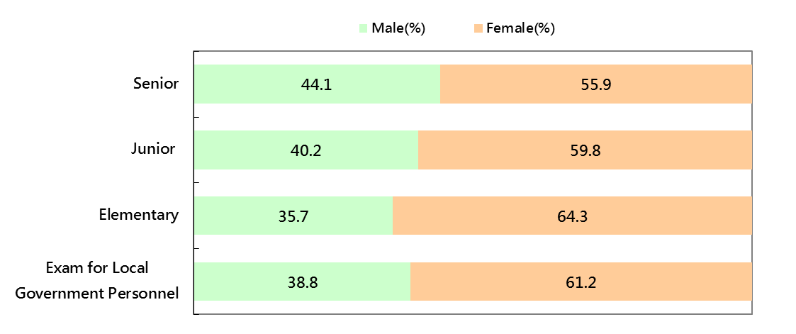
Figure 1-1 Percentages of registered candidates of Civil Service Examinations by type (2017)

Source: Ministry of Examination.
Note: 1. Senior Civil Service Examinations are classified into level 1, level 2 and level 3.
Note: 2. Examination for Local Government Personnel are classified into grade 3, grade 4 and grade 5.

Figure 1-2 Percentages of female registered candidates of Civil Service Examinations by type (2013-2017)

Source: Ministry of Examination.

Figure 1-3 Examination attendance rate of Civil Service Examinations by type (2017)

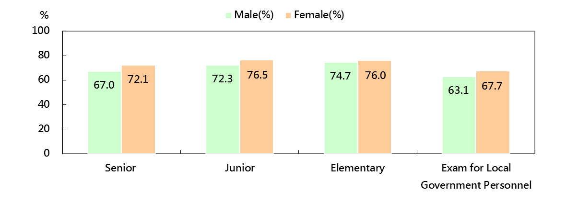

Source: Ministry of Examination
Note: Examination attendance rate = (Number of actual examinees / Number of registered candidates) × 100%

Figure 1-4 Examination attendance rate of Civil Service Examinations by type (2013-2017)

Exam for Local
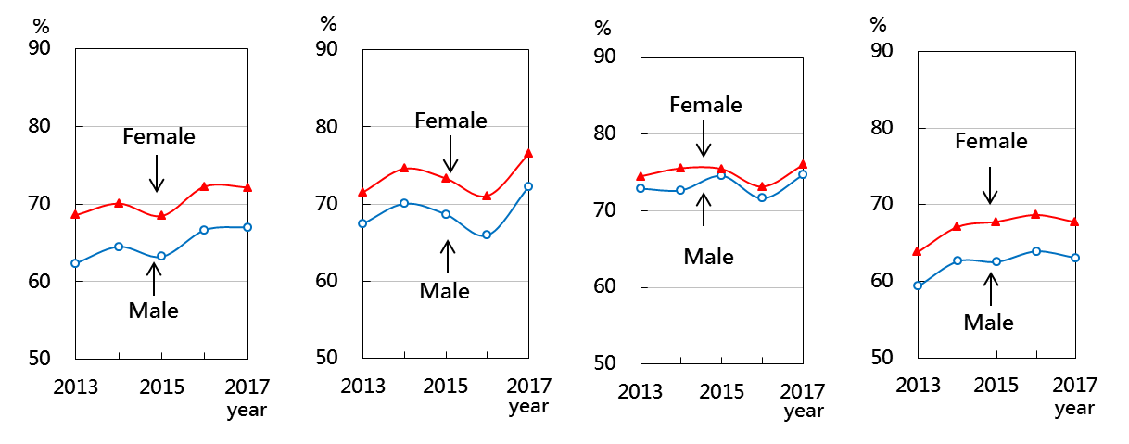
Government Senior Junior Elementary Personnel

Source: Ministry of Examination

Figure 1-5 Percentages of qualified examinees of Civil Service Examinations by type (2017)

Source: Ministry of Examination

Figure 1-6 Qualification rate of Civil Service Examinations by type (2013-2017)

Examfor Local
Government
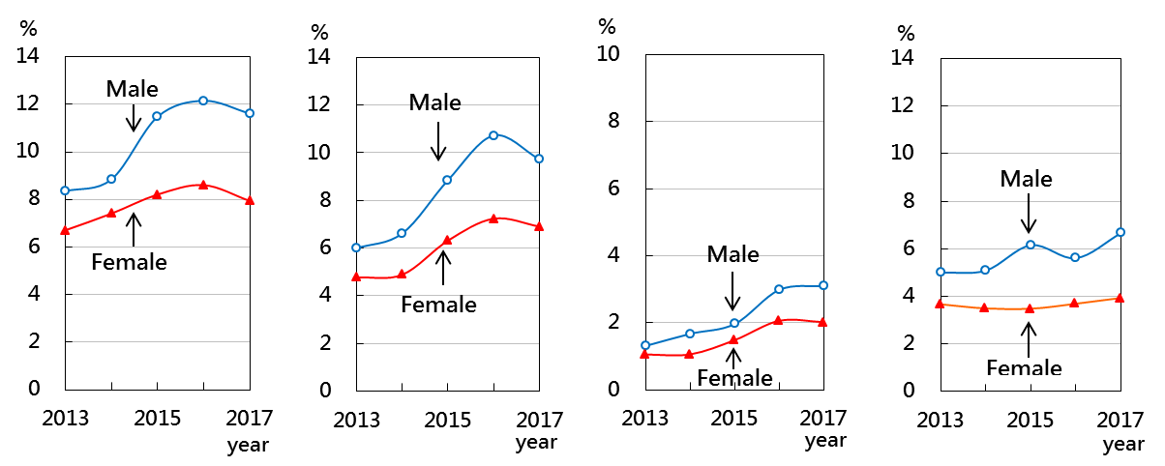
Senior Junior Elementary Personnel

Source: Ministry of Examination
Note: Qualification rate = (Number of qualified examinees/Number of actual examinees)×100%

1.2 Civil Service Examinations by administrative personnel and technicians

Figure 1-7 Percentages of registered candidates of administrative personnel in Civil Service Examinations by type (2013-2017)

Exam for Local
Government
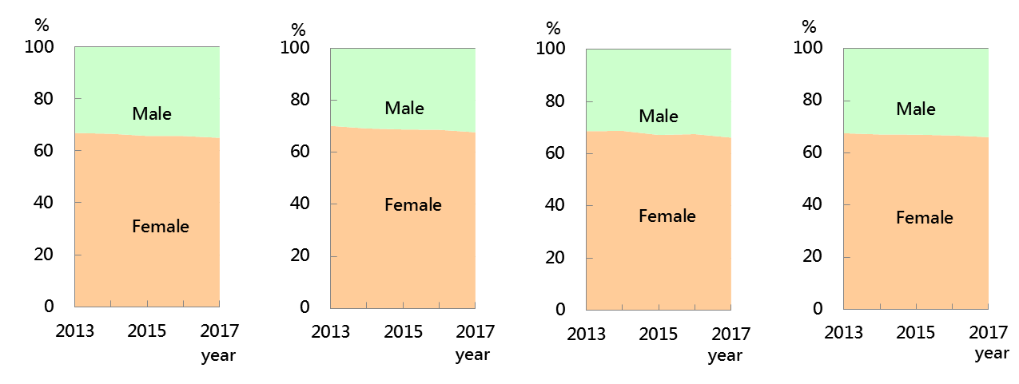
Senior Junior Elementary Personnel

Source: Ministry of Examination

Figure 1-8 Percentages of registered candidates of technicians in Civil Service Examinations by type (2013-2017)
Exam for Local
Government
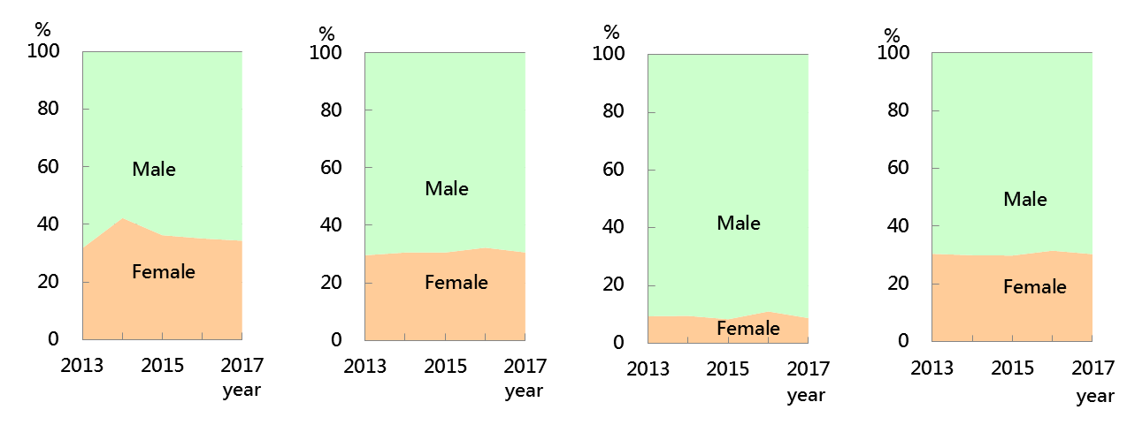
Senior Junior Elementary Personnel

Source: Ministry of Examination

Figure 1-9 Percentages of qualified examinees of administrative personnel in Civil Service Examinations by type (2013-2017)

Exam for Local
Government
Senior Junior Elementary Personnel

Source: Ministry of Examination

Figure 1-10 Percentages of qualified examinees of technicians in Civil Service Examinations by type (2013-2017)

Exam for Local
Government
Senior Junior Elementary Personnel
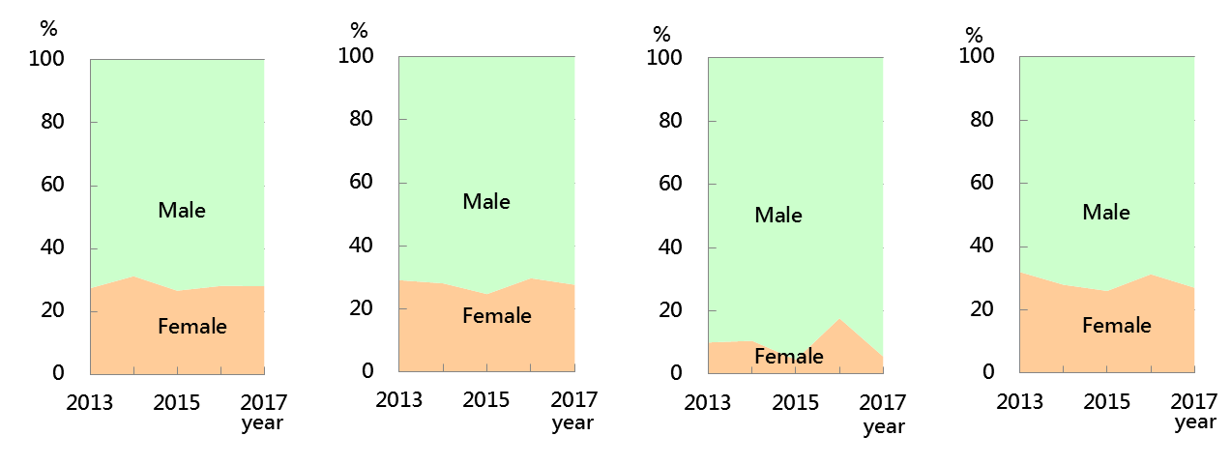

Source: Ministry of Examination

Figure 1-11 Qualification rate of administrative personnel in Civil Service Examinations by type (2013-2017)
Exam for Local
Government
Senior Junior Elementary Personnel

Source: Ministry of Examination

Figure 1-12 Qualification rate of technicians in Civil Service Examinations by type (2013-2017)
Exam for Local
Government

Senior Junior Elementary Personnel

Source: Ministry of Examination

1.3 Special Civil Service Examinations

Figure 1-13 Percentages of qualified examinees of Special Civil Service Examinations by examination name (2017)

Source: Ministry of Examination

Figure 1-14 Percentages of qualified examinees of Special Civil Service Examinations by examination name (2013-2017)

Exam for Local

Exam for Indigenous Government Exam for the

Peoples Personnel Disabled

Source: Ministry of Examination

Figure 1-15 Gender Disparity in the percentages of qualified examinees of Special Civil Service Examinations in select examination names (2013-2017)

Exam for Police Exam for General Exam for Coast Officers Police Admittance Guard Personnel

Exam for Immigration Exam for Civil Exam for Taxation

Administrators Aviation Personnel Personnel

Source: Ministry of Examination

Note: No Taxation Personnel Examination was held in 2014 and 2016.
Chapter 2 Professional and Technical Examinations

Figure 2-1 Percentages of registered candidates and qualified examinees of Senior Professional and Technical Examinations (2017)

Registered candidates Qualified examinees

Source: Ministry of Examination

Figure 2-2 Percentages of registered candidates and qualified examinees of Senior Professional and Technical Examinations by category (2017)

Registered candidates Qualified examinees

Source: Ministry of Examination

Figure 2-3 Percentages of registered candidates and qualified examinees of Junior Professional and Technical Examinations (2017)

Registered candidates Qualified examinees

Source: Ministry of Examination

Figure 2-4 Percentages of registered candidates and qualified examinees of Junior Professional and Technical Examinations by category (2017)

Registered candidates Qualified examinees

Source: Ministry of Examination
Chapter 3 Civil Servants

Figure 3-1 Civil servants by agency (end of 2017)
Unit: person ; %

Source: Ministry of Civil Service
Note: Data include civilian personnel of administration, public enterprises, public health services and public schools, not including teachers, military personnel, security guards and contract employees.

Figure 3-2 Percentages of female civil servants by agency (end of 2013-2017)

Source: Ministry of Civil Service

Figure 3-3 Percentages of female civil servants by county(city) (end of 2017)

Source: Ministry of Civil Service

Figure 3-4 Percentages of level of education of civil servants (end of 2017)

Source: Ministry of Civil Service

Figure 3-5 Percentages of civil servants by rank (end of 2017)

Source: Ministry of Civil Service

Figure 3-6 Percentages of female civil servants by rank (end of 2013-2017)

Source: Ministry of Civil Service

Figure 3-7 Percentages of civil servants by age (end of 2017)

Source: Ministry of Civil Service

Figure 3-8 Percentages of civil servants as supervisors (end of 2016)

Source: Ministry of Civil Service

Figure 3-9 Percentages of indigenous civil servants by personnel category (end of 2017)

Source: Ministry of Civil Service

Figure 3-10 Percentages of disabled civil servants by personnel category (end of 2017)

Source: Ministry of Civil Service

Figure 3-11 Civil servants applying for parental leave without pay and restoration (2013-2017)

Source: Civil Servants Qualification Review Database, Ministry of Civil Service.
Note: 1.Application data include civil servants applying for parental leave without pay registered by Ministry of Civil Service in each year, not including teachers and public enterprise personnel without Ministry of Civil Service qualification review.
2.Restoration data refer to civil servants restoring from parental leave without pay reviewed by Ministry of Civil Service each year.

Figure 3-12 Percentages of civil servants applying for parental leave without pay and restoration by the period of leave (2017)

Source: Civil Servants Qualification Review Database, Ministry of Civil Service.
Note: Number of application persons in 2017 =100; Number of restoration persons in 2017 =100

Chapter 4 Screening and Review Results of Civil Servants Performance Evaluation

Figure 4-1 Percentages of screening and review results of civil servants performance evaluation by gender (2016)

Source: Civil Servants Performance Rating Database, Ministry of Civil Service.

Figure 4-2 Percentages of screening and review results of civil servants performance evaluation by ranking (2016)

Source: Civil Servants Performance Rating Database, Ministry of Civil Service.

Figure 4-3 Percentages of screening and review results of civil servants performance evaluation by rank (2016)

Source: Civil Servants Performance Rating Database, Ministry of Civil Service.
Note: Screening and review results of Judge and Prosecutor performance evaluation consist of two categories: ”Excellent" and ”Not Up to Excellent”.

Figure 4-4 Percentages of performance evaluation results for civil servants restoring from parental leave without pay (2016)
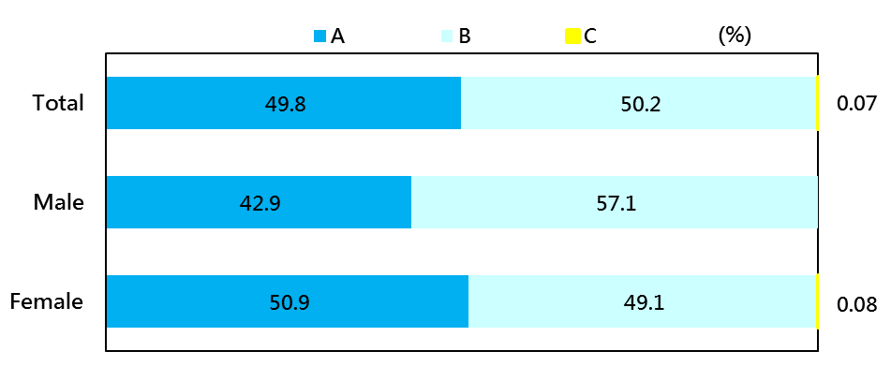

Source: Civil Servants Performance Rating Database, Ministry of Civil Service.

Figure 4-5 Number of civil servants receiving Distinguished Achievement Award by agency (2017)

Source: Ministry of Civil Service

Figure 4-6 Number of civil servants receiving Distinguished Achievement Award by rank (2017)
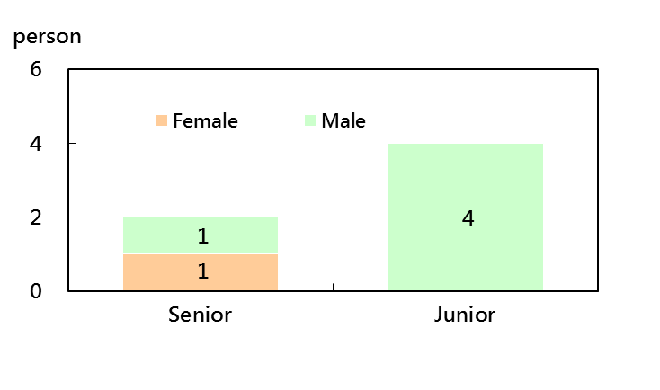

Source: Ministry of Civil Service

Figure 4-7 Percentages of civil servants receiving Model Civil Servants Award by agency (2017)
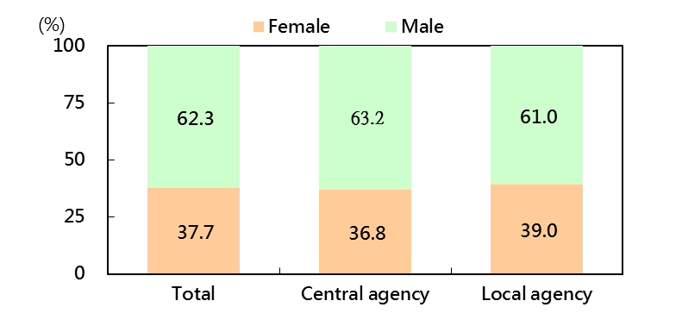

Source: Ministry of Civil Service

Figure 4-8 Percentages of civil servants receiving Model Civil Servants Award by rank (2017)
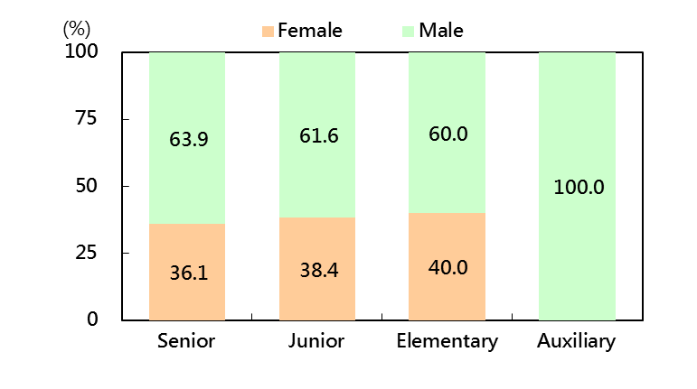

Source: Ministry of Civil Service

Chapter 5 Training and Development for Civil Servants

5.1 Basic training

Figure 5-1 Percentages of training for Civil Service Exam and Special Civil Service Exam qualifiers (2013-2017)
Training for Elementary, Junior and Training for Special Civil
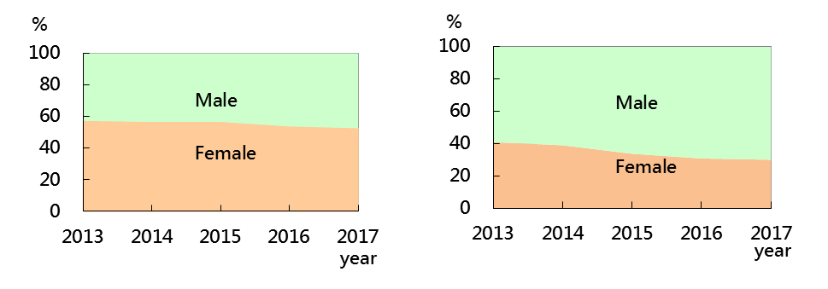
Senior Civil Service Exam qualifiers Service Exam qualifiers

Source: Civil Service Protection and Training Commission

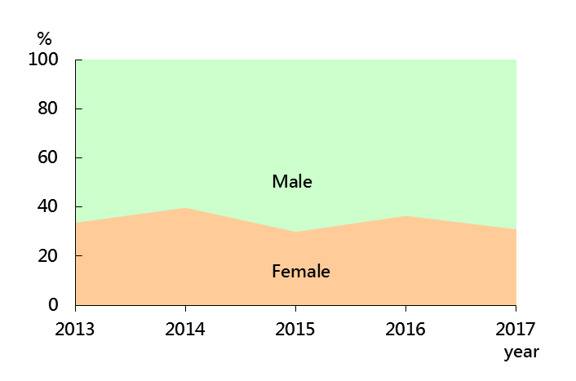
Figure 5-2 Percentages of retaining training qualification for Elementary, Junior and Senior Civil Service Exam qualifiers(2013-2017)

Source: Civil Service Protection and Training Commission

Figure 5-3 Qualification rate of training for Civil Service Exam and Special Civil Service Exam qualifiers (2013-2017)
Training for Elementary, Junior and Training for Special Civil
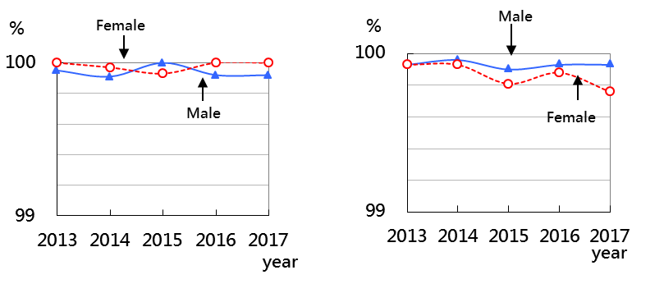
Senior Civil Service Exam qualifiers Service Exam qualifiers

Source: Civil Service Protection and Training Commission

5.2 On-the-job training

Figure 5-4 Percentages of on-the-job training for civil servants by rank (2013-2017)
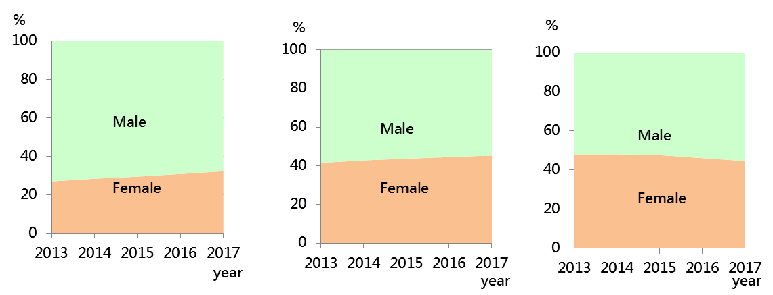
Senior Junior Elementary

Source: Civil Service Protection and Training Commission

Figure 5-5 The average of on-the-job training hours for civil servants by rank (2013-2017)
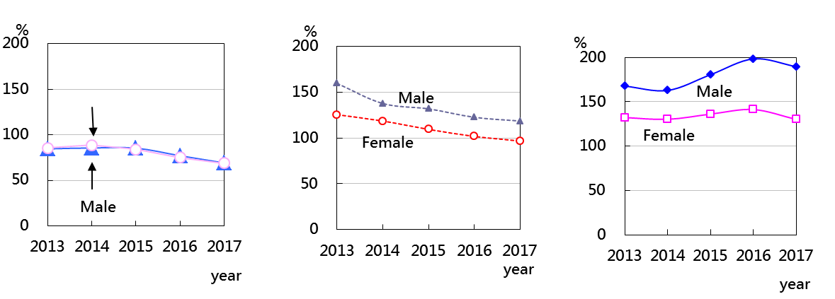
Senior Junior Elementary

Source: Civil Service Protection and Training Commission

5.3 Development training

Figure 5-6 Percentages of promotion training by type (2017)
Unit: person; %

Junior to Senior Rank Elementary to Junior Rank
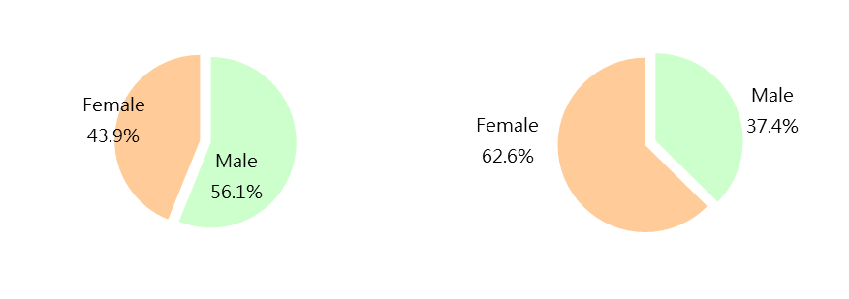
promotion training promotion training
(1,199) (1,668)

Police Major to Superintendent Rank Police Sergeant to Major Rank
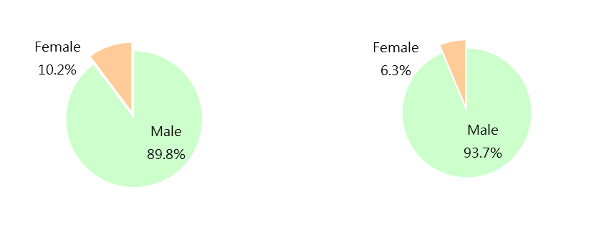
Promotion training Promotion training
(88) (1,098)

Source: Civil Service Protection and Training Commission

Figure 5-7 Percentages of promotion training by type (2013-2017)
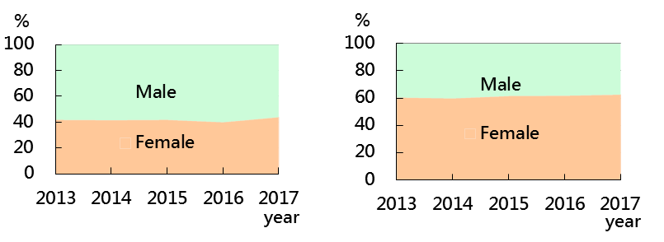
Junior to Senior Rank Elementary to Junior Rank
promotion training promotion training

Police Major to Superintendent Rank Police Sergeant to Major Rank
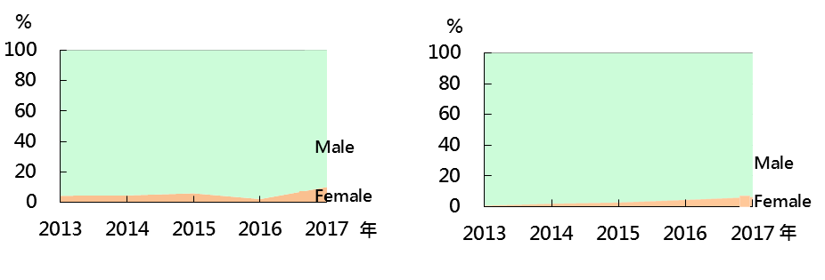
Promotion training Promotion training

Source: Civil Service Protection and Training Commission

Figure 5-8 Qualification rate of Junior to Senior rank promotion training and Elementary to Junior rank promotion training (2013-2017)

Junior to Senior Rank Elementary to Junior Rank
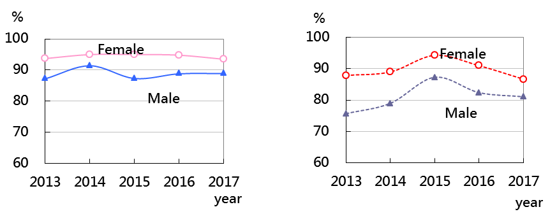
promotion training promotion training

Source: Civil Service Protection and Training Commission

Figure 5-9 Qualification rate of Junior to Senior rank promotion training of Police Officers and Elementary to Junior rank promotion training of Police Officers (2013-2017)

Junior to Senior rank promotion training of Police Officers
Elementary to Junior rank promotion training of Police Officers

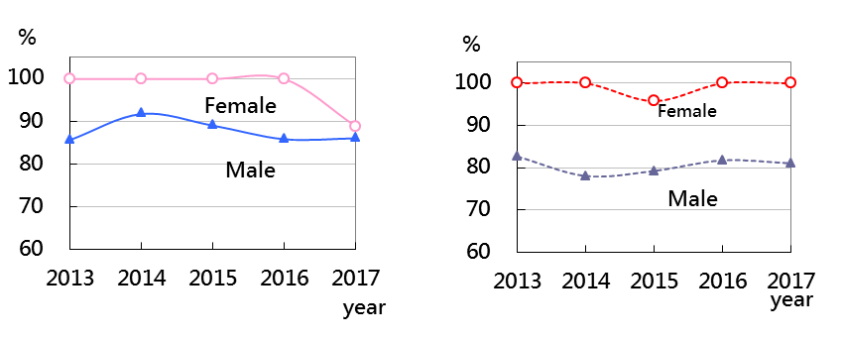

Source: Civil Service Protection and Training Commission

Figure 5-10 Percentages of developing training for Senior civil servants (2013-2017)

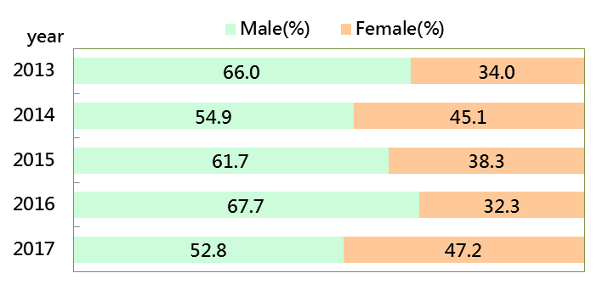

Source: Civil Service Protection and Training Commission

Figure 5-11 Percentages of developing training for Senior civil servants by type (2017)

Management Leadership Strategy
Development Development Dvelopment
Training Training Training
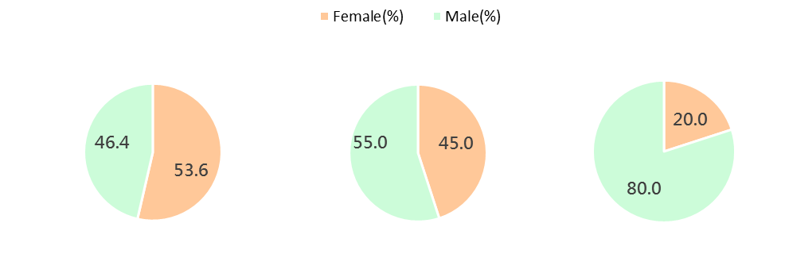

Source: Civil Service Protection and Training Commission

Figure 5-12 Percentages of counsellor of training for Civil Service Exam and Special Civil Service Exam qualifiers (2013~2017)
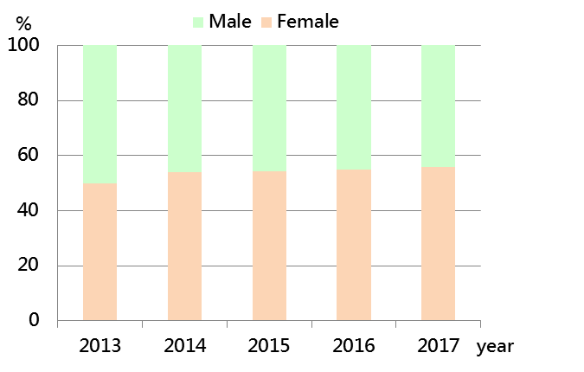

Source: National Academy of Civil Service

Figure 5-13 Percentages of counsellor of promotion training (2013~2017)

Junior to Senior Rank Promotion Training
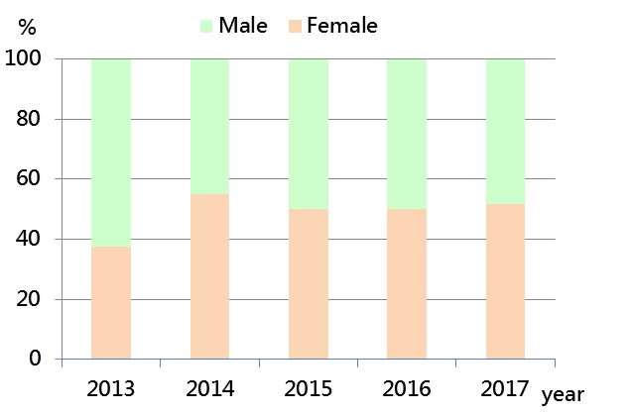

Elementary to Junior Rank Promotion Training
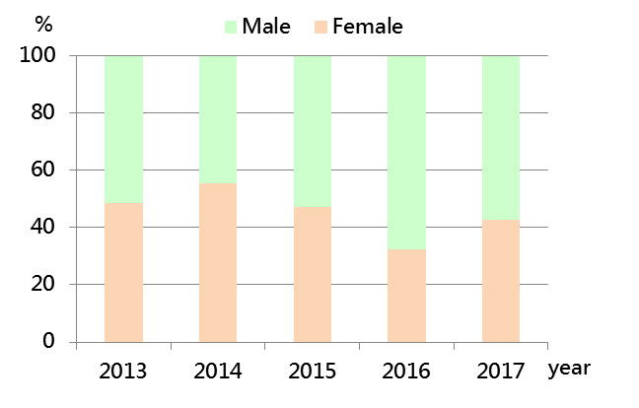

Source: National Academy of Civil Service

Chapter 6 Retirement and Survivor Relief of Civil Servants

Figure 6-1 Overview of civil servants retirement review by type (2017)

Unit: person ; %

Source: Civil Servants Retirement and Survivor Relief Database, Ministry of Civil Service

Figure 6-2 Percentages of civil servants retirement review by rank (2017)

Source: Civil Servants Retirement and Survivor Relief Database, Ministry of Civil Service

Figure 6-3 Average age of civil servants retirement review by rank (2017)

Male Female

Source: Civil Servants Retirement and Survivor Relief Database, Ministry of Civil Service

Figure 6-4 Number of civil servants voluntary retirement review by age (2017)

Source: Civil Servants Retirement and Survivor Relief Database, Ministry of Civil Service
Note:The reach retirement's age of civil servants is 65 years old except for judges and prosecutors (majority of 70 years old).

Figure 6-5 Percentages of civil servants survivor relief review by type (2013-2017)

Death of illness or accident Death of official duties

Source: Civil Servants Retirement and Survivor Relief Database, Ministry of Civil Service

Figure 6-6 Percentages of civil servants survivor relief review by age (2017)

Source: Civil Servants Retirement and Survivor Relief Database, Ministry of Civil Service

Chapter 7 Personnel of Examination Yuan and Subordinate Agencies

Figure 7-1 Overview of employees of Examination Yuan and subordinate agencies by gender (end of 2017)

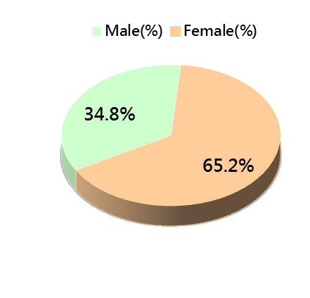
Unit: person ; %

Total: 864

Source: Examination Yuan

Figure 7-2 Percentages of personnel of Examination Yuan and subordinate agencies by agency (end of 2017)

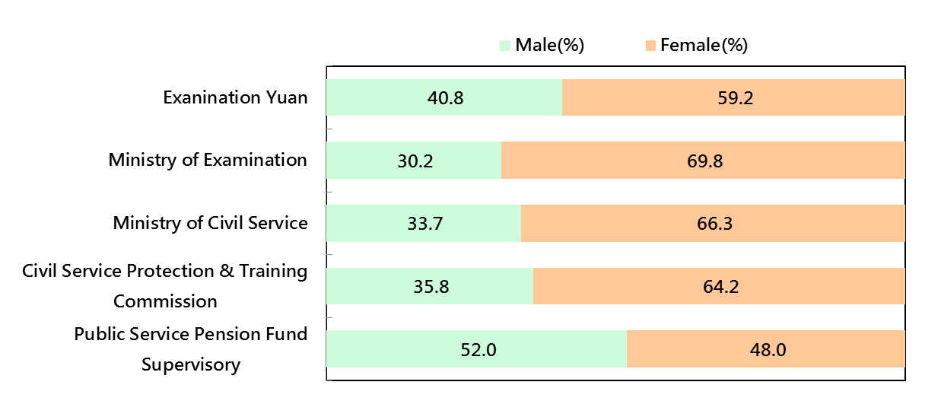

Source: Examination Yuan

Figure 7-3 Percentages of personnel of Examination Yuan and subordinate agencies by rank (end of 2017)
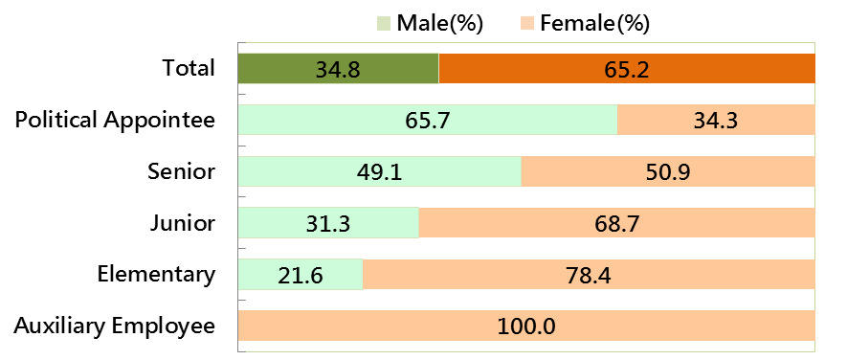

Source: Examination Yuan

Figure 7-4 Percentages of female employees of Examination Yuan and subordinate agencies by rank (end of 2013-2017)
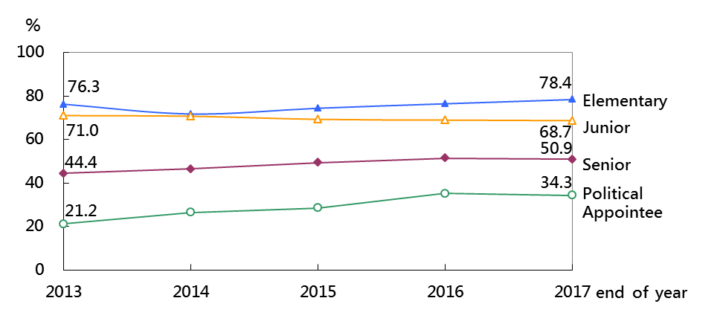

Source: Examination Yuan

