**1011000700**



**101 1 20**



|  |  |
| --- | --- |
|  |  |
|  | 2 |
|  | 2 |
|  | 2 |
|  | 6 |
|  | 7 |
|  | 8 |
|  | 10 |
|  | 18 |
|  | 19 |
| **1---** | 20 |
| **2---** | 28 |

1



1. 6 18 11 39



4



99 12 2 11 114



4



2 5



1. 1



(Development Training)



2



Competency







3







99



129.3



128.8 80.2







4

1



|  |  |  |  |  |  |  |  |  |  |  |  |  |  |  |  |  |  |  |  |  |  |  |  |  |  |  |  |  |
| --- | --- | --- | --- | --- | --- | --- | --- | --- | --- | --- | --- | --- | --- | --- | --- | --- | --- | --- | --- | --- | --- | --- | --- | --- | --- | --- | --- | --- |
|  | | | | | | | | | | | | | | | | | | | | | |  | | | |  | |  |
|  |  |  | |  | |  | |  | |  | | |  | | |  | | |  | | |  | | |  | | |  | | |
| 1090 1749 | | | | | | | | 366 | | | 262 | | | 66 | | | 75 | | | 73 | | | 41 | | | 32 | | | 24 | | | 1 | 5 | | 3784 |
|  | | 1129 | | 1141 | | 358 | | 135 | | 81 | | | 8 | | | 20 | | | 0 | | | 152 | | | 189 | | | 1 | | | 15 | | 3229 | | | |
|  | | 590 | | 612 | | 40 | | 45 | | 27 | | | 6 | | | 5 | | | 2 | | | 6 | | | 0 | | | 3 | | | 19 | | 1355 | | | |
|  | | 186 | | 244 | | 30 | | 0 | | 12 | | | 0 | | | 0 | | | 0 | | | 27 | | | 10 | | | 16 | | | 385 | | 910 | | | |
|  | | 333 | | 416 | | 5 | | 1 | | 3 | | | 0 | | | 0 | | | 0 | | | 0 | | | 0 | | | 0 | | | 0 | | 758 | | | |
|  | | 3328 | | 4162 | | 799 | | 443 | | 189 | | | 89 | | | 98 | | | 43 | | | 217 | | | 223 | | | 21 | | | 424 | | 10036 | | | |







1. 100 10 31



7,013



1,355 1,668



7,490



1,242 278



141 440 445



1. 2



43 51



204



5

2: 95 -99



|  |  |  |  |  |  |  |  |  |  |  |
| --- | --- | --- | --- | --- | --- | --- | --- | --- | --- | --- |
|  | |  | |  | |  | |  | |  |
| 95 | 168 | 379 | 38 | | 32 | | 37 | | 33 | |
| 96 | 215 | 214 | 46 | | 26 | | 43 | | 26 | |
| 97 | 223 | 276 | 66 | | 51 | | 60 | | 45 | |
| 98 | 178 | 163 | 41 | | 14 | | 26 | | 23 | |
| 99 | 234 | 188 | 62 | | 40 | | 49 | | 33 | |
|  | 204 | 244 | 51 | | 33 | | 43 | | 32 | |







1. 100 10 31



6



1. 100



98 7 15



5



1. 2 9



98 99



Analytic Hierarchy Process AHP



360



7







8







9



**98**年以前規



劃過程

高階文官核心職能重



構（含項目、定義及



關鍵行為指標）



高階文官學習地圖



**99**年及**100** 年試辦訓練



檢討

高階文官培訓飛



躍方案

運用評鑑中心法嚴謹



選訓實施計畫



依據職能行為指標



設計對應之課程



進行**360**度職能回饋



年度訓練計



畫



以職能為規劃基礎，運用多元評鑑工具之訓練



1







1



10

7



2



8



3



9



1



2

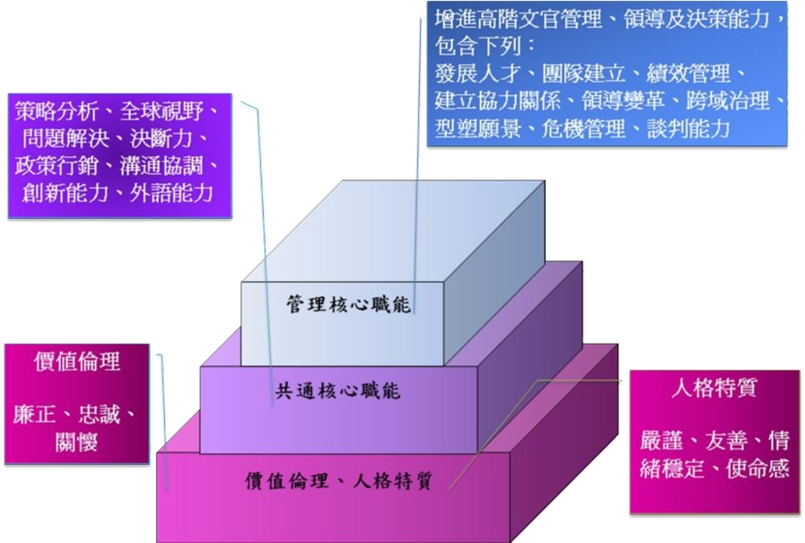

On-the-Job Training,



OJT Off -the-Job Training, Off-JT



11

Self development, SD OJT



OJT



Off-JT



SD



Off-JT



OJT SD



2







71 1



1. 5







12



1. Management Development Training,MDT







A



1. 2



B



1. 1 6 35



1. Leadership Development Training,LDT







A 2



B 4



1. 1 2 25



1. Strategy Development Training,SDT







A



2



B



1. 1 2 20



13



1



2



/















1. /



14



1



1



2



3



2



3



1. 3



2







15



1 2 3



4



3











1



16



2



1. 6 360



17



**SDT**



G13-G14



**LDT**

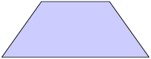

G12



**MDT**

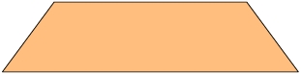

G10-G11

主



管



2



17



14



18



2 3



|  |  |  |  |
| --- | --- | --- | --- |
|  |  |  |  |
|  |  |  |  |
| 1 |  |  | 5 |
| 2 |  |  | 3 |
| 3 |  |  | 1 |
| 4 |  |  | 1. 3 10 80 300  2. 3 |
| 5 |  | 1.  2. | 1.  2. 2 |
| 6 |  |  | 6 |
| 7 |  |  | 1. 2  2. |
| 8 |  |  | 3 |
| 9 |  |  | 2 |

19

